Kualif Flutter – CC

App: Starbucks

1. Login Page

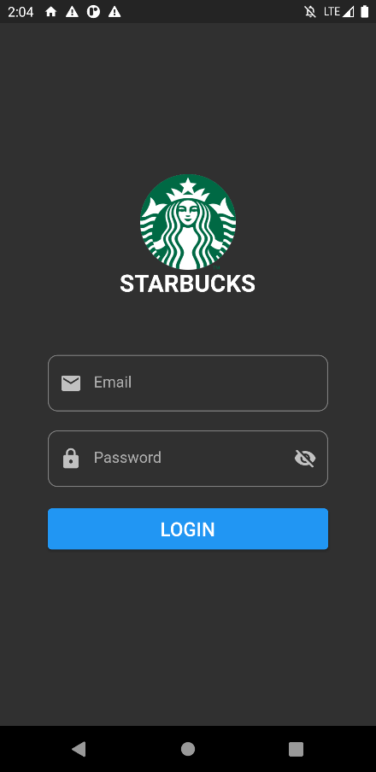Logo: Starbucks

Validations:

* Email must not be empty
* Password must not be empty
* Email must be valid (contains ‘@’, ‘.com’, not ‘@.com’)
* Password must be at least 8 characters
* Password must not contain symbols
* Password must be alphanumeric

1. Home Page

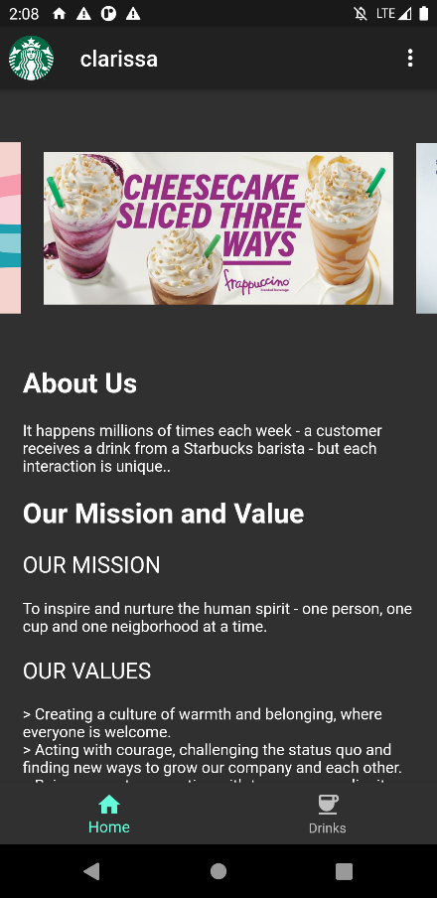Navigation Bar:

Bottom Navigation Bar:

Navigation Menu (Home, Drinks)

App Bar: Login username (substring from email)

Pop Up Menu:

Pop Up Menu Item (Change Theme, Logout)

Image Carousel ✓

Infographics: (About Us, Our Mission and Value)

1. Drinks Page

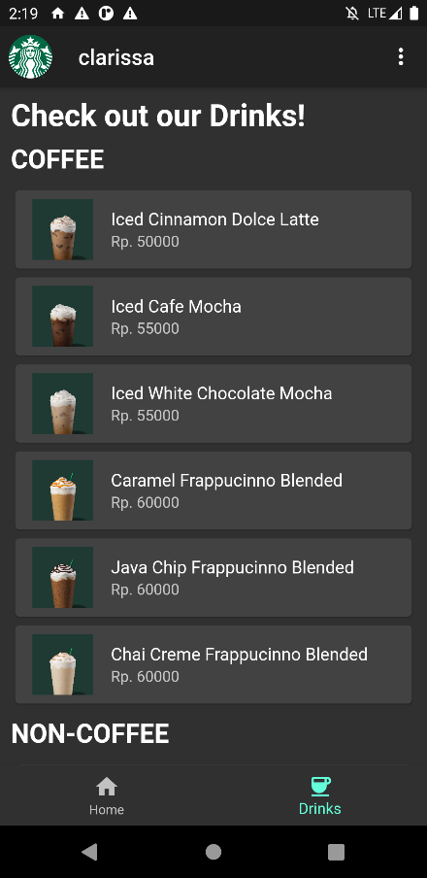List of Menu (Coffee and Non-Coffee):

Each of menu is displayed in Card (ListTile)

Image ✓

Name ✓

Price ✓

Redirect to Drink Detail Page ✓

1. Drink Detail Page (Detail)

First Tab:

Item Image ✓

Description ✓

Price ✓

Add review field ✓

Snackbar when review is empty ✓

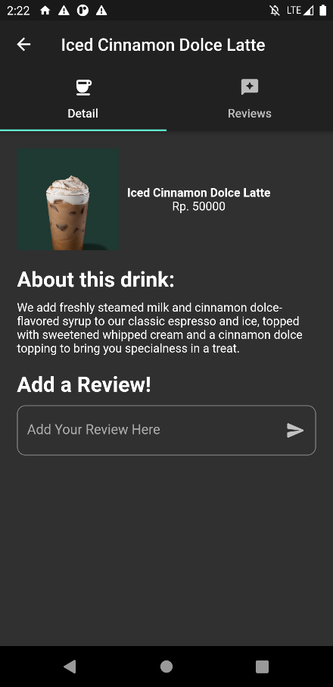

1. Drink Detail Page (Reviews)

Second Tab:

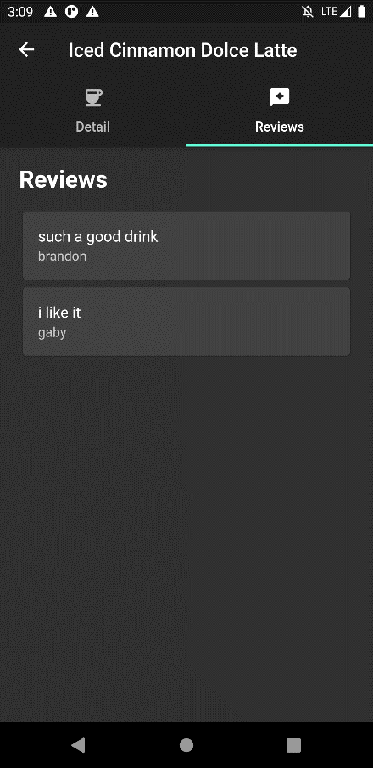Display list of reviews and reviewers ✓